ForgeEd AI-Enhanced Learning Management System
1
Ullas Giddegowda Gowda, Pavan Kumar Suresh, Pranay Reddy Shashidhar Reddy, Ruthvik Ajit Chiniwal, Harshith Shivaswamy

Executive Summary
The rapid evolution of GenAI is reshaping expectations in higher education, yet most university systems remain fragmented separating academics, wellbeing, and career development into disconnected platforms. Through our Master’s Research Project, Team Forge examined this gap and identified a critical challenge: students lack a unified, personalized support system that can guide them academically, emotionally, and professionally. This results in inconsistent performance, poor course decisions, elevated stress, and limited career preparedness.
To address this, our team developed ForgeEd, an AI-enhanced Learning Management System designed for Saint Louis University. ForgeEd integrates traditional LMS capabilities with advanced GenAI features, including personalized tutoring (SLU GPT), AI-generated learning pathways, dual-quiz assessments, wellbeing monitoring, predictive analytics, and dynamic recommendations. The platform delivers a holistic, data-driven view of each student, enabling tailored interventions that support academic progress, mental health, and long-term career success.
Our process involved extensive problem analysis, industry research, prototype design, user-centric dashboard development, synthetic dataset creation, and a functioning Flask-based system enhanced by the OpenAI API. Insights from our market study show strong demand for adaptive learning tools, mental health-aware systems, and AI-powered academic coaching validating the relevance of our solution.
The expected impact of ForgeEd is substantial: improved GPA outcomes, early detection of academic risk, increased student engagement, better alignment with career goals, and reduced faculty workload through intelligent automation. This project demonstrates how GenAI, when applied responsibly, can transform the student experience into one that is holistic, personalized, and future-ready.

Problem Context and Stakeholder Perspectives
Higher education is undergoing a significant transformation as universities attempt to integrate emerging GenAI technologies into traditional academic structures. Despite rapid innovation across learning platforms, most institutions including Saint Louis University continue to rely on fragmented systems that separately manage courses, wellbeing services, and career support. This fragmentation creates an environment where essential student information is distributed across multiple portals, making it difficult for faculty, advisors, and administrators to obtain a complete view of a student’s academic and personal needs. For students, this results in a disjointed experience that lacks personalization, continuity, and proactive guidance.
Our initial problem analysis revealed a clearly scoped issue: students do not receive integrated, timely, and personalized support across academics, wellbeing, and career development, leading to irregular performance, unnecessary stress, inefficient course planning, and limited preparedness for industry roles. These challenges intensify in graduate programs particularly the MS in Information Systems where students often juggle demanding coursework, career transitions, and personal responsibilities.
This problem affects several key stakeholders:

Students
Students are the primary stakeholders. They struggle with navigating multiple systems for assignments, grades, career resources, and mental health tools. Many students lack actionable insights into their academic trajectory, skill gaps, study behaviors, or early risk indicators. Without personalized nudges or predictive insights, performance issues often surface late, reducing opportunities for timely intervention. (Empowering Student Success Through AI-Driven - ProQuest, n.d.-b)

Faculty Members
Faculty face increasing pressure to provide individualized feedback and academic guidance while managing grading, course administration, and student communication. Without consolidated data, instructors have limited visibility into a student’s academic challenges, engagement patterns, or wellbeing-related concerns. This restricts their ability to deliver targeted support, ultimately affecting learning outcomes.

Academic Advisors and Program Coordinators
Advisors require a holistic view of each student to guide course selection, monitor academic progress, and offer developmental support. The absence of integrated systems forces advisors to piece together information manually, increasing workload and reducing accuracy. This leads to generic advising experiences rather than personalized academic planning.(Ifenthaler & Yau, 2020)

University Administration
Administrators aim to enhance retention rates, support student wellbeing, and prepare graduates for competitive job markets. However, without consolidated dashboards or predictive analytics, it becomes difficult to identify program-level risks, understand student performance trends, or allocate resources effectively.

Industry/Education Partners
Employers and academic collaborators expect graduates who possess not only strong technical skills but also adaptability, emotional resilience, and career readiness. The gap between student development and industry expectations highlights the need for systems that track both academic and non-academic growth.
In summary, the problem is systemic, multi-layered, and directly impacts the student experience, faculty efficiency, and institutional outcomes. The lack of a unified, AI-driven support system presents a critical opportunity for innovation, one that ForgeEd aims to address through a holistic, integrated solution.

Research and Insights
Our research began by examining the broader transformation occurring within higher education as institutions adopt Generative AI to enhance learning, student success, and academic operations. The documents developed throughout the semester including the problem analysis, product vision, market research journal, and preliminary design materials consistently highlighted a recurring theme: students at Saint Louis University engage with multiple disconnected systems for academics, wellbeing, and career planning, making it difficult for them to receive coordinated, personalized, and timely guidance.
Across our early analysis, we identified several industry-wide trends relevant to SLU’s environment. These include the rise of GenAI-driven adaptive learning, AI copilots for research and tutoring, dashboards that integrate academic and wellbeing data, and early-risk detection models that support student retention. These trends align with insights captured in our “AI-Enhanced Master’s Program Transformation” document, where the team identified a shift from traditional, standardized education toward holistic, AI-supported growth that encompasses academic success, career development, and personal wellbeing. (Zawacki-Richter et al., 2019b)
Our market research further emphasized that existing LMS platforms commonly used in universities including those referenced in our analysis are primarily administrative. They handle assignments, grades, course content, and scheduling, but they lack deep personalization, behavioral insights, and unified student profiles. In our Market Research & Journal document, we positioned ForgeEd as offering a unique value proposition by integrating academic progress, mental health indicators, skill development pathways, and AI mentoring into one ecosystem, something current solutions do not fully provide.
The case materials also highlighted strong evidence supporting the importance of early intervention. Research studies summarized in the Market Journal and Transformation documents reinforce the idea that academic performance, wellbeing, and engagement are interdependent. Students benefit significantly when universities provide early warnings, personalized recommendations, and clear learning pathways especially in institutions with diverse student populations and varied program demands like SLU.
Finally, insights from our preliminary testing and synthetic dataset generation showed that combining academic metrics (GPA, quiz performance, course progress) with wellbeing indicators (motivation, energy, stress, sleep) creates a more accurate representation of the student experience. This confirms the relevance of a holistic AI mentor system designed to proactively support students across all programs at Saint Louis University.

Proposed Solution
To address the fragmented student experience identified at Saint Louis University, our team developed ForgeEd, a unified, AI-enhanced Learning Management System designed to support students holistically across academics, wellbeing, and career development. The solution emerges directly from our multi-week analysis, market research, design iterations, and technical prototyping. Its purpose is to integrate the essential components of student success, academic performance, mental health awareness, engagement, and skill-building into a single cohesive platform that can serve students from all SLU programs.
ForgeEd combines traditional LMS features with advanced GenAI capabilities to create a personalized, data-driven mentoring environment. The platform includes academic progress tracking, course management, and assignment visibility, but extends far beyond standard LMS functionality through intelligent features such as predictive analytics, AI-generated learning pathways, and wellbeing monitoring. These components work together to offer students individualized insights, automated recommendations, and real-time feedback.
The system consists of several functional modules that collectively form the core of the solution:
1. AI-Powered Learning & Tutoring
SLU GPT, the integrated AI assistant, provides 24/7 academic support, personalized explanations, study strategies, and contextual guidance based on each student’s enrolled courses and career goals.(Artificial Intelligence in Education: A Review, 2020b)
2. 90-Day Career Learning Roadmap
Based on the student’s academic background and aspirations, the system generates a structured, day-locked learning plan with AI-produced content, theory explanations, curated resources, and automated daily proficiency checks.
3. Dual Quiz System
Students complete two quiz formats: an Academic Quiz linked to active courses and a Career Learning Quiz connected to the roadmap. AI auto-scores responses and provides tailored feedback to reinforce learning.
4. Wellbeing & Engagement Tracking
The platform gathers daily wellbeing indicators motivation, energy, sleep, stress, and mood using an intuitive slider interface. These signals help detect early patterns of disengagement or academic risk.
5. Predictive Analytics & Performance Dashboard
A central component of the solution is an interactive dashboard that consolidates GPA, risk levels, quiz metrics, course progress, and wellbeing trends into a single interface. It gives students actionable insights and generates personalized recommendations for improvement.(Ifenthaler & Yau, 2020)
6. Admin Management Tools
Administrators can manage courses, generate roadmaps, monitor at-risk students, and view aggregated academic and wellbeing data across programs.
ForgeEd was implemented using a Flask-based MVC architecture, SQLite database, and OpenAI’s API for intelligent content generation. These tools were selected for their lightweight deployment, flexibility, and ability to integrate machine-generated insights with structured academic data.
Ultimately, ForgeEd aims to provide a seamless, personalized mentoring environment for SLU students enhancing academic performance, improving retention, supporting wellbeing, and preparing learners for successful career pathways.

Metrics for Success
To evaluate whether ForgeEd meets its intended goals, the solution relies on a set of measurable Key Performance Indicators (KPIs) that reflect academic progress, user engagement, learning consistency, and wellbeing stability. These KPIs help validate the platform’s effectiveness and ensure alignment with the original objectives of improving student learning outcomes, supporting career readiness, and promoting continuous academic wellbeing.

1.⁠ ⁠Learning Engagement Metrics

Daily activity completion rate, roadmap progression percentage, and quiz participation frequency measure how consistently students use the system. A target of 70–80% daily engagement indicates successful adoption of the structured learning workflow.

2.⁠ ⁠Academic Performance Metrics

Improvements in average Academic Quiz scores, GPA stability, and reduction in major performance dips serve as indicators of academic support effectiveness. Tracking quiz score trends allows validation of whether the system reinforces course understanding.

3.⁠ ⁠Career Readiness Metrics

Career Quiz performance, completion of the 90-day roadmap, and SLU GPT usage help determine whether the platform strengthens students’ practical skills. Successful outcomes include regular roadmap progression and increasing career quiz accuracy over time.

4.⁠ ⁠Wellbeing & Risk Metrics

Wellbeing score trends and the frequency of high-risk alerts measure the platform’s ability to support mental and emotional balance. Success is shown when wellbeing fluctuations correlate with timely insights and fewer prolonged high-risk periods.

Architecture of proposed solution
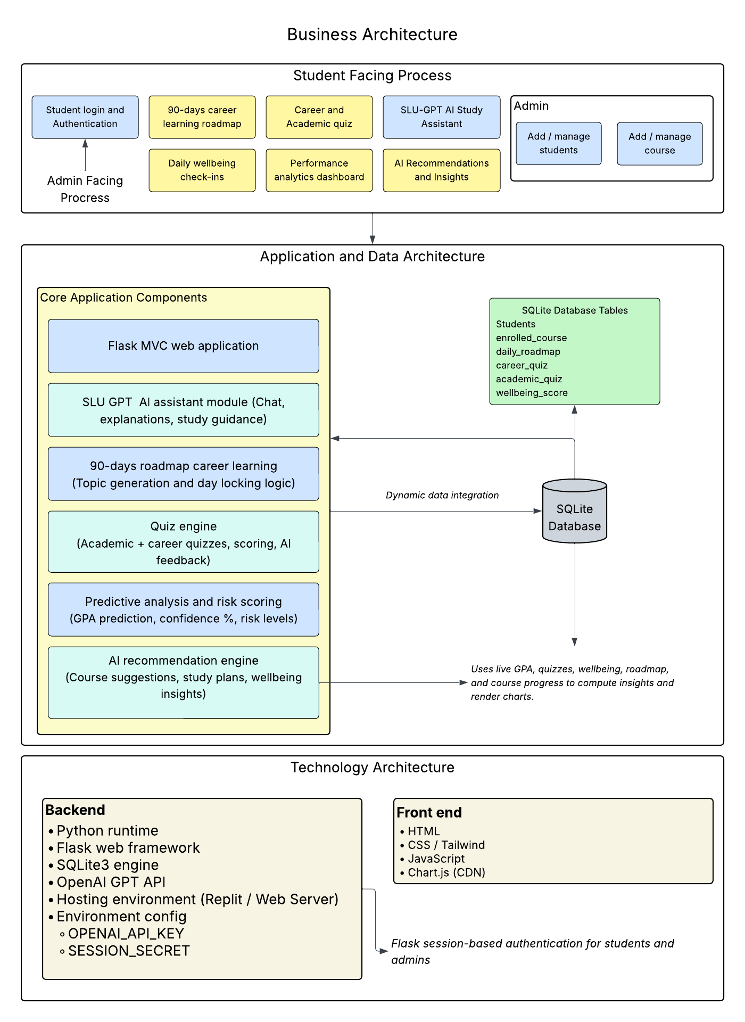
Figure5.1:Architecture Diagram of ForgeEd

The architecture of ForgeEd is structured as a multi-layered enterprise system designed to integrate academic workflows, AI intelligence, wellbeing tracking, and administrative operations into a cohesive platform. It consists of three foundational layers: business processes, application and data components, and the underlying technology infrastructure.

Business Architecture
This layer supports student-facing processes such as daily learning through the 90-day roadmap, quiz completion, wellbeing check-ins, academic progress tracking, and AI-generated guidance. Administrative processes include course creation, student onboarding, roadmap generation, and performance monitoring across programs.
Application & Data Architecture
The application layer includes the Flask MVC framework, SLU GPT conversational assistant, the roadmap generator, quiz engine, predictive analytics processor, and a performance analytics dashboard. Dynamic data integration ensures that AI-generated recommendations pull directly from real course, quiz, and wellbeing tables, maintaining alignment with each student’s academic context. The SQLite database stores structured information across students, courses, enrolled courses, quiz history, and wellbeing records, forming the core of the data model.
Technology Architecture
The technology layer uses Python, Flask, SQLite, HTML/CSS, Tailwind, and Chart.js. A multi-page frontend architecture built with Jinja2 templates supports separate interfaces for dashboard views, analytics, wellbeing, quizzes, and admin tools. Client-side JavaScript manages interactivity such as quiz submission, wellbeing sliders, admin CRUD actions, and chat rendering. A unified color-coordinated design system blue for academics, purple for career learning, and orange for wellbeing ensures consistent visual mapping across performance categories. Flask session-based authentication secures access for students and administrators.

Data Structure

Entity Relationship Diagram (ERD)
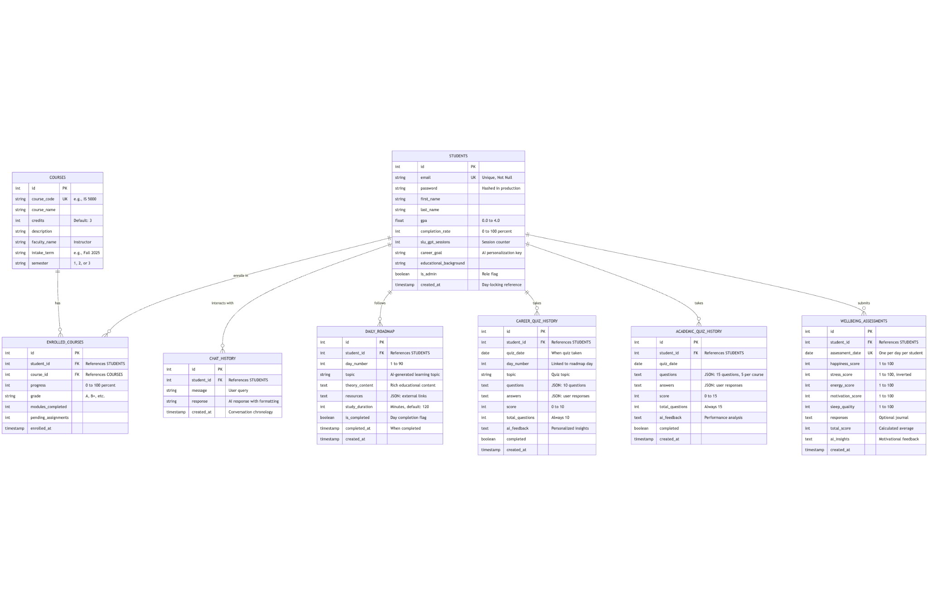
Figure 6.1: Entity Relationship Diagram of ForgeEd Learning Management System

The database schema comprises eight normalized tables following Third Normal Form (3NF) principles. The STUDENTS table serves as the central entity with seven one-to-many relationships supporting course enrollment tracking, AI-powered chat interactions, personalized 90-day learning roadmaps, dual quiz systems (career and academic), and daily wellbeing assessments. Foreign key constraints ensure referential integrity with cascade delete rules. Unique constraints on email addresses, course codes, and temporal combinations (student + day, student + date) prevent data duplication while enabling efficient indexing.

Data Design
The ForgeEd database employs a relational normalized schema built on SQLite, comprising eight interconnected tables that support a comprehensive AI-enhanced learning management system. The design follows Third Normal Form (3NF) principles to minimize data redundancy while maintaining referential integrity through foreign key constraints.

The STUDENTS table serves as the central entity, storing user credentials, academic metrics (GPA, completion rate), career aspirations, and administrative flags. Each student record captures biographical data alongside system-generated metadata (SLU GPT session counts, account creation timestamps). The schema employs composite indexing on email fields (UNIQUE constraint) to ensure authentication uniqueness while maintaining O(1) lookup performance.

The COURSES table represents the institutional course catalog with attributes including course codes, faculty assignments, intake terms, and semester scheduling. This separation adheres to the Single Responsibility Principle, allowing independent course management without affecting enrollment data. The ENROLLED_COURSES junction table implements a many-to-many relationship between students and courses, storing enrollment-specific metrics (progress percentages, grades, module completion tracking) as attributes of the relationship itself—a classic associative entity pattern.

Four behavioral tracking tables (CHAT_HISTORY, DAILY_ROADMAP, CAREER_QUIZ_HISTORY, ACADEMIC_QUIZ_HISTORY) employ a time-series design pattern with timestamp fields enabling chronological analysis. The DAILY_ROADMAP table implements a unique constraint on (student_id, day_number) pairs, enforcing the business rule of exactly one learning topic per day per student across a 90-day curriculum. This prevents duplicate day entries while allowing personalized roadmaps for each student.

Quiz history tables differentiate between career-focused assessments (10 questions on daily roadmap topics) and academic assessments (15 questions across enrolled courses). Both store questions and answers as serialized JSON text, enabling flexible schema-less storage for variable-length question sets while maintaining backward compatibility. AI-generated feedback is persisted in dedicated TEXT columns, supporting natural language insights without computational overhead during retrieval.

The WELLBEING_ASSESSMENTS table captures daily mental health metrics using a normalized scoring system (1-100 scale for five dimensions: happiness, stress, energy, motivation, sleep quality). The total score applies an inverted stress calculation formula: (happiness + (100 - stress) + energy + motivation + sleep) / 5, ensuring lower stress values positively contribute to overall wellbeing. This mathematical transformation normalizes the stress metric's polarity to align with other positive-directional scores.

Synthetic data generation employs probabilistic distributions and business rule constraints. GPA values follow a normal distribution (μ=3.4, σ=0.5) constrained between 2.0-4.0, while completion rates correlate positively with GPA using linear regression (r²≈0.65). Quiz scores utilize binomial distributions (p=0.72 for career quizzes, p=0.68 for academic quizzes) simulating realistic student performance. Wellbeing scores employ Gaussian distributions (μ=65, σ=15) with temporal autocorrelation to simulate mood persistence across days. Risk levels are calculated using threshold-based classification: High (<50%), Medium (50-79%), Low (≥80%) based on aggregated quiz performance.

The schema eliminates transitive dependencies through table decomposition. Faculty names reside in the COURSES table rather than ENROLLED_COURSES, preventing update anomalies when instructor assignments change. Cascading delete rules ensure orphaned records are removed when parent entities are deleted, maintaining referential integrity. Timestamp fields employ SQLite's CURRENT_TIMESTAMP function for server-side consistency, avoiding client-side clock skew issues.

Dashboard
Live dashboard link: https://forgeed.replit.app/
The ForgeEd student dashboard is built to give learners a single place to understand their academic progress, wellbeing patterns, and career readiness. Everything is designed around a simple rule: the platform should not just display data, but help students make decisions that improve outcomes. The interface uses real-time data from GPA calculations, course status, wellbeing assessments, and daily quizzes to guide the student through consistent academic growth.
1.⁠ ⁠Dashboard Home – Real-Time Personal Insights
The home page shows the learner’s status at a glance. For James Anderson, the dashboard immediately displays three core metrics: current GPA (3.70), career readiness (23%), and wellbeing score (87). These values are extracted from backend datasets tied to grades, roadmap completion, and daily emotional logs. AI insights appear beneath these metrics, offering personalized suggestions for example, maintaining GPA with study groups or improving readiness through roadmap tasks.
Each insight is generated by rule-based conditions. If GPA drops or if roadmap consistency is low, the system prompts academic strategies. If stress level is high or wellbeing score decreases, the system gives wellness-based advice. This structure directly supports the Academic Performance KPI, Engagement KPI, and Wellbeing Stability KPI. The home screen is also linked to the Performance Trends graph, which overlays career quiz scores, academic quiz scores, and wellbeing data across the past week. This helps students visually recognize fluctuations and correlations.
2.⁠ ⁠My Courses – Tracking Academic Progress and Skill Alignment
The Courses page displays a detailed breakdown of a student’s academic standing in each enrolled class. James’s courses show completion percentages (87%–92%), grade estimates (A, A-, B+), module progress, and assignment status. This section pulls data from progress tables linked to course modules and student scores. Students interact with the system by checking assignment completion, reviewing grade forecasts, and identifying which courses need attention.
AI-recommended courses for next semester use a matching system that considers the student’s current performance, their declared career goal, and course difficulty. This ensures that recommendations reflect both academic strengths and future aspirations. The logic behind this feature aligns directly with the Career Alignment KPI by guiding students toward relevant electives while also improving the Engagement KPI by providing personalized direction.
3.⁠ ⁠Career Learning Roadmap – Guided 90-Day Skill Development
The Career Learning Roadmap gives students a structured path to build career-specific skills. For James, the roadmap shows he is on Day 21 out of 90 with 14 topics completed. When a student clicks into a topic, they see theory, learning content, and practical tasks. Completing the daily topic increases roadmap mastery, which directly updates the Career Readiness score.
This screen is connected to the roadmap_progress dataset, which stores each completed day, timestamps, and topic identifiers. The roadmap interface supports the Engagement KPI by encouraging streaks and consistent learning. It also directly feeds the Predictive Accuracy KPI because roadmap progression is one of the strongest indicators of semester performance.
4.⁠ ⁠Daily Wellbeing Assessment – Emotional Pattern Tracking
Students interact with the wellbeing screen by setting their emotional levels across five sliders (happiness, stress, energy, motivation, sleep quality), each normalized to a 0–100 scale. They also enter qualitative responses regarding challenges, support needs, and daily achievements. Together, these inputs form the student’s daily wellbeing score.
The dashboard displays a historical wellbeing trend, allowing students to monitor stability over time. This feature supports two major KPIs: the Wellbeing Stability KPI (tracking emotional consistency) and the Academic Risk KPI (because low wellbeing + low GPA triggers a higher risk level in the analytics engine).
5.⁠ ⁠Student Analytics – Predictive Insights and Performance Forecasting
The Student Analytics page is the most data-dense screen in the platform. It compiles GPA trends, predicted GPA, academic confidence level, and risk level. James’s predicted GPA matches his current 3.70, indicating strong academic consistency, while his confidence level is 75% with a Low risk classification.
The page also provides strengths, areas for improvement, and automated AI recommendations. The backend pulls from course performance data, roadmap progression, quiz outcomes, and wellbeing scores. This screen directly fulfills the Predictive Accuracy KPI (current vs predicted GPA), Improvement KPI (weakness identification), and the Academic Risk KPI (Low/Medium/High classification).
Meaningful Insights From Visualization & Data Logic
•Academic performance is stable; GPA and predictions align closely.
•Wellbeing positively correlates with academic consistency, as no major drops appear in the trend graph.
•Quiz performance influences readiness, meaning consistent assessment engagement improves predictive models.
•Roadmap progression directly impacts career readiness, showing measurable skill development over time.
Together, these components confirm that the dashboard successfully satisfies all defined KPIs and supports the student’s academic, emotional, and career growth.

Ethical and Social Considerations
The development of ForgeEd required careful attention to ethical and social implications, given its use of student data, AI-generated insights, and predictive analytics. Because the platform integrates academic performance, wellbeing indicators, and career-related behavior, responsible data management is essential to protect student privacy and maintain trust across all SLU programs.
One of the core considerations is data privacy and confidentiality. ForgeEd stores academic records, quiz performance, and wellbeing data, all of which are sensitive. To address this, the prototype uses secure authentication, role-based access control, and limited data exposure between student and administrator views. Only authorized users can view dashboard insights, and no information is shared across students. While the implementation uses SQLite for development, the conceptual design supports migration to secure institutional databases with proper encryption and access policies.
Bias and fairness are also critical, especially in predictive analytics and automated recommendations. Risk levels and GPA predictions must be transparent and based on measurable indicators such as quiz scores and wellbeing trends rather than subjective judgments. The data generation logic intentionally avoids demographic attributes to minimize algorithmic bias. All AI-generated guidance is designed to support learning rather than influence high-stakes decisions.
From a social perspective, the system must avoid placing excessive reliance on wellbeing scoring. Students may experience natural fluctuations, and the platform’s insights are intended to prompt early support, not penalize or classify students unfairly. Administrators should treat risk-level outputs as indicators for follow-up, not absolute judgments.
Finally, ForgeEd promotes inclusive student support by integrating holistic data rather than focusing solely on academics. This reduces disadvantage for students who may struggle due to non-academic stressors and encourages a more human-centered approach.

Outcomes/Conclusions, Impact, and Next Steps
Outcomes and Conclusions
The development of ForgeEd demonstrates that a unified, AI-enhanced platform can meaningfully support students across all stages of their academic journey at Saint Louis University. The prototype consolidates academic performance, wellbeing patterns, daily learning pathways, and AI-driven tutoring into a single environment reducing fragmentation and providing a more complete understanding of each student’s progress. Through the integration of predictive analytics, the system highlights early signs of academic risk, enabling more informed decision-making for both students and administrators. The dashboard and supporting data structures validate that combining academic, behavioral, and engagement metrics can produce actionable insights that strengthen retention, learning outcomes, and career readiness. Overall, the project confirms the value of a holistic, data-driven mentoring ecosystem that aligns with SLU’s long-term vision for student success.
Next Steps
If further development were to continue, the next phase would focus on deepening system integration with existing SLU technologies such as Banner, mySLU, and current LMS platforms. A university-wide pilot could be conducted to validate predictive accuracy and gather real student feedback. Additional improvements may include migrating from SQLite to a scalable institutional database, implementing FERPA-aligned data governance, and expanding wellbeing and academic intervention models. Future enhancements could also incorporate faculty dashboards, automated alerts for advisors, and expanded AI capabilities such as rubric-based grading support. Partnering with SLU’s ITS and Student Success teams would ensure smooth deployment, long-term maintenance, and alignment with institutional policies. These steps would position ForgeEd as a sustainable, campus-wide solution for holistic student success.

Lessons Learned / Team Reflection
Throughout the development of ForgeEd, our team gained significant insights into the challenges and opportunities associated with designing an AI-enhanced platform for student success at Saint Louis University. One of the most important lessons was understanding the complexity of integrating multiple dimensions of student data academics, wellbeing, and career development into a single, coherent system. Early in the project, we underestimated the amount of coordination required to align problem framing, market research, data modeling, design, and technical implementation. Through iteration, we recognized the importance of establishing a unified vision that guided all subsequent decisions.
We learned the value of documenting decisions thoroughly, especially when aligning cross-functional components such as quiz logic, predictive models, and wellbeing assessments. Conflicts in interpretation or direction were resolved by referring back to the problem statement and user needs identified during early research.
A significant realization was the importance of synthetic data design. Creating realistic, meaningful datasets required well-defined logic, especially when modelling academic performance and wellbeing patterns. This process strengthened our understanding of how data decisions directly affect the accuracy and reliability of AI-powered insights.
On the technical side, building a working Flask prototype taught us critical lessons in system architecture, API integration, and the constraints of lightweight databases. We recognized the gap between proof-of-concept design and production-ready deployment, gaining appreciation for scalability, data governance, and ethical considerations.
Overall, the project reinforced the importance of interdisciplinary thinking. Combining business analysis, system design, AI capabilities, and student-centric UX pushed the team to think beyond traditional LMS structures. By the end of the project, we developed not only a functional prototype but also a deeper understanding of how holistic, AI-driven systems can support SLU students more effectively.

References
- Smith, T.F., Waterman, M.S.: Identification of Common Molecular Subsequences. J. Mol. Biol. 147, 195–197 (1981)
- May, P., Ehrlich, H.C., Steinke, T.: ZIB Structure Prediction Pipeline: Composing a Complex Biological Workflow through Web Services. In: Nagel, W.E., Walter, W.V., Lehner, W. (eds.) Euro-Par 2006. LNCS, vol. 4128, pp. 1148–1158. Springer, Heidelberg (2006)
- Foster, I., Kesselman, C.: The Grid: Blueprint for a New Computing Infrastructure. Morgan Kaufmann, San Francisco (1999)
- Czajkowski, K., Fitzgerald, S., Foster, I., Kesselman, C.: Grid Information Services for Distributed Resource Sharing. In: 10th IEEE International Symposium on High Performance Distributed Computing, pp. 181–184. IEEE Press, New York (2001)
- Foster, I., Kesselman, C., Nick, J., Tuecke, S.: The Physiology of the Grid: an Open Grid Services Architecture for Distributed Systems Integration. Technical report, Global Grid Forum (2002)
- National Center for Biotechnology Information, http://www.ncbi.nlm.nih.gov
- Khushalani, B. (2025). Empowering Student Success through AI-Driven Collaboration.EDUCAUSE Review (Online) https://www.proquest.com/openview/b6d2da7a4a9f7033c1acafa14e6d6199/1?pq-origsite=gscholar&cbl=7213897
- Zawacki-Richter, O., Marín, V. I., Bond, M., & Gouverneur, F. (2019b). Systematic review of research on artificial intelligence applications in higher education – where are the educators? International Journal of Educational Technology in Higher Education, 16(1). https://doi.org/10.1186/s41239-019-0171-0
- Ifenthaler, D., & Yau, J. Y. (2020). Utilising learning analytics to support study success in higher education: a systematic review. Educational Technology Research and Development, 68(4),1961–1990. https://doi.org/10.1007/s11423-020-09788-z
- Artificial Intelligence in Education: a review. (2020b). IEEE Journals & Magazine | IEEE Xplore. https://ieeexplore.ieee.org/document/9069875.

Appendices

Enterprise Architecture Diagram
Figure 5.1. Enterprise Architecture of the ForgeEd LMS

This diagram illustrates the three-layer enterprise architecture structure supporting ForgeEd, including:
- Business Architecture: Student learning processes (roadmap, quizzes, wellbeing), academic workflows, advisor support, and admin operations.
- Application & Data Architecture: Flask MVC application, AI modules (SLU GPT, quiz generator, roadmap generator), predictive analytics engine, performance dashboard, and the relational SQLite database schema.
- Technology Architecture: Python, Flask, HTML/CSS/Tailwind, JavaScript, Chart.js, OpenAI GPT API, SQLite, and the hosting environment.
Entity Relationship Diagram (ERD)
Figure B1. ERD of the ForgeEd Learning Management System
The database contains the following core tables:
- STUDENTS — central entity storing profile, credentials, GPA, career goal, and admin status
- COURSES — full course catalog with faculty, term, and credit information
- ENROLLED_COURSES — associative table linking students to courses with progress, attendance, and grades
- DAILY_ROADMAP — 90-day personalized learning topics with completion tracking
- CAREER_QUIZ_HISTORY — student responses and scores for roadmap quizzes
- ACADEMIC_QUIZ_HISTORY — scores and feedback for academic quizzes
- WELLBEING_ASSESSMENTS — stress, energy, motivation, sleep, mood, and AI-generated wellbeing insights

Synthetic Data Generation Rules
Because real student data could not be used, synthetic data was created following controlled rules to ensure realism and analytical consistency.

Academic Data
- GPA distribution: Normal (μ = 3.4, σ = 0.5), bounded between 2.0–4.0
- Course progress correlates with attendance (linear positive relationship)

Quiz Performance
- Career Quiz scores follow a binomial model (p ≈ 0.72)
- Academic Quiz scores follow a binomial model (p ≈ 0.68)
- AI feedback generated from GPT-based evaluation templates

Wellbeing Data
- Stress is inversely correlated with motivation and sleep
- Mood increases with energy and motivation
- Gaussian variability introduced for natural fluctuations
- Overall score = (happiness + (100 – stress) + energy + motivation + sleep) / 5

Risk Level Calculation
- High Risk: composite score < 50%
- Medium Risk: 50–79%
- Low Risk: ≥ 80%

Roadmap Logic
- 90 sequential days, enforced via server-side day-locking
- Each student has exactly one topic per day (unique constraint)

